# **Assignment Research Internship**

## 

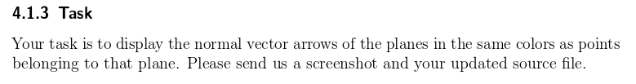

**Ans 4.1.3**

### **Image**:

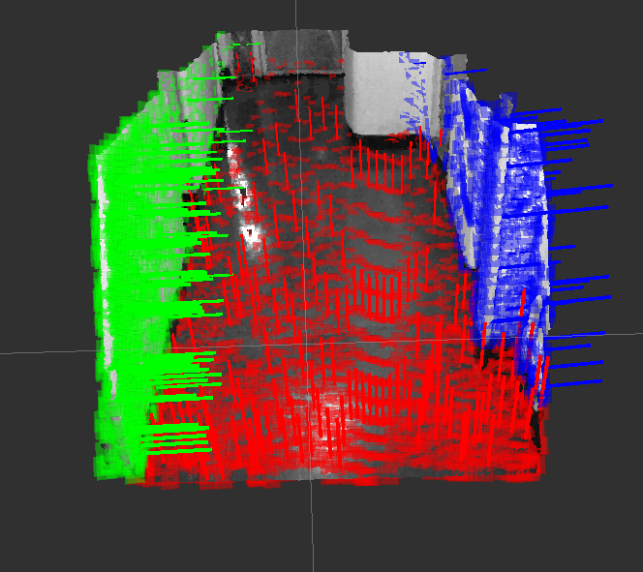

### **CODE**



**Ans 4.2**

Basic steps followed to reconstruction -

1. Disparity Map from image pair. - openCV - <http://docs.opencv.org/2.4/modules/calib3d/doc/camera_calibration_and_3d_reconstruction.html#stereosgbm-stereosgbm>
2. 3D point cloud from disparity map. - Szeliski’s book and Learning OpenCV by G. Bradski. Summarised well by folowing links - <http://stackoverflow.com/questions/27374970/q-matrix-for-the-reprojectimageto3d-function-in-opencv>  
     
   <http://stackoverflow.com/questions/11406849/using-opencv-to-generate-3d-points-assuming-frontal-parallel-configuration>
3. Transformation to world Frame.
4. Combining all point clouds to give one single cloud.

Suitable adjustments made:

1. Histogram equalisation is highly context dependent and will adversely affect the correlation between pixels corresponding to the same point by uneven equalisation. Leading to poor disparity, thus it should be an unlikely improvement unless the images are totally lacking in contrast.
2. The gradient operator will reduce informational difference between two low contrast area of different shade thus causing reduced matching performance. Though it does improve matching around edges. What would work really well are image processing algorithms which improve feature matching by reducing noise, while possibly improving edge contrast.
3. **Statistical Outlier removal** applied, making the reconstruction consistent by filtering out stray points and patches.
4. Treid **ICP**, requires minimal alignment for functionality .

**Other References**

Projection

<http://wiki.ros.org/image_pipeline/CameraInfo>

<http://docs.opencv.org/2.4/modules/calib3d/doc/camera_calibration_and_3d_reconstruction.html#stereosgbm-stereosgbm>

Disparity

<http://www.cvlibs.net/software/libelas/>

<http://answers.opencv.org/question/9503/how-to-increase-the-quality-of-disparity-map/>

<http://www.jayrambhia.com/blog/disparity-maps/>

<http://blog.martinperis.com/2011/08/opencv-stereo-matching.html>

<https://cseautonomouscar2012.wordpress.com/2012/11/14/comparison-of-some-stereo-vision-algorithms/>

Reprojection to 3D

<http://www.vision.caltech.edu/bouguetj/calib_doc/htmls/parameters.html>

<http://docs.opencv.org/2.4/modules/calib3d/doc/camera_calibration_and_3d_reconstruction.html#stereosgbm-stereosgbm>

<http://docs.opencv.org/master/dd/d53/tutorial_py_depthmap.html#gsc.tab=0>

<http://docs.ros.org/api/sensor_msgs/html/msg/CameraInfo.html>

<https://www.ptgrey.com/KB/10102>

<https://courses.cs.washington.edu/courses/cse455/09wi/Lects/lect16.pdf>

Following are snapshots of the 3D - View generated also attached *.pcd files.

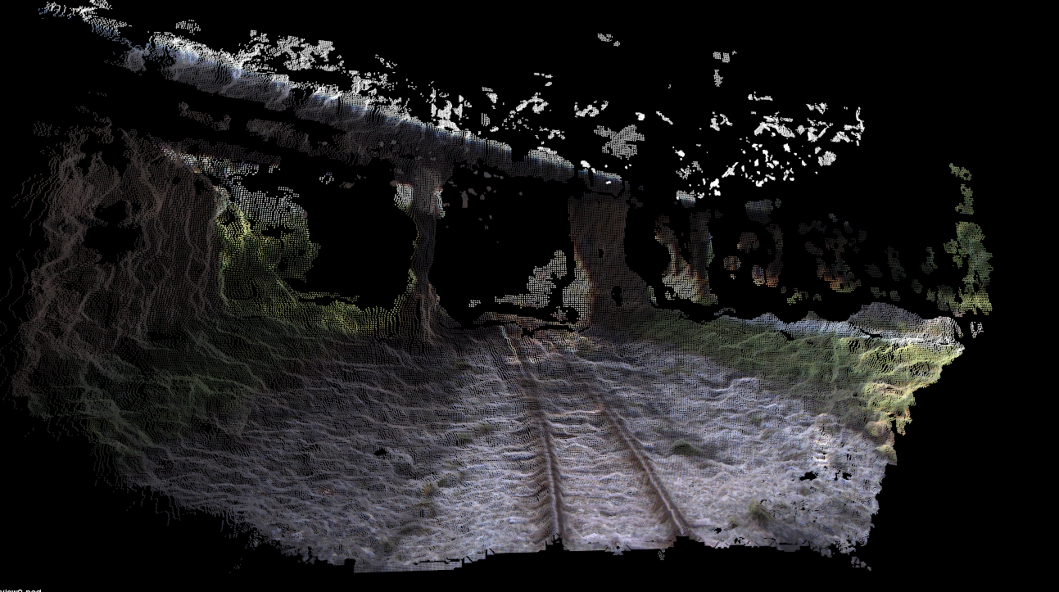

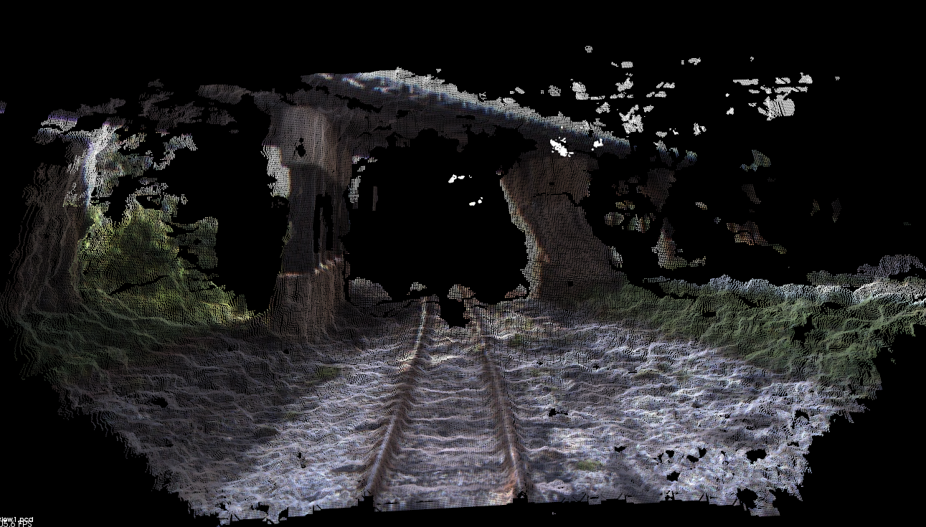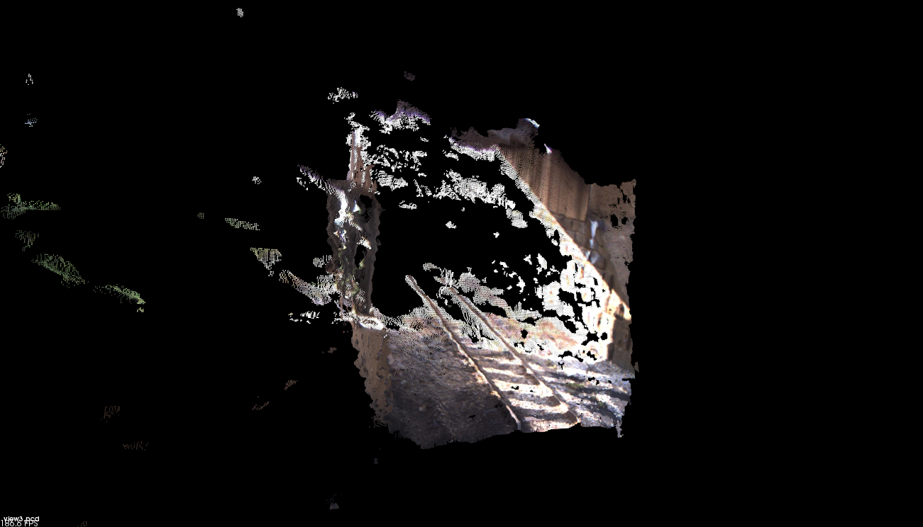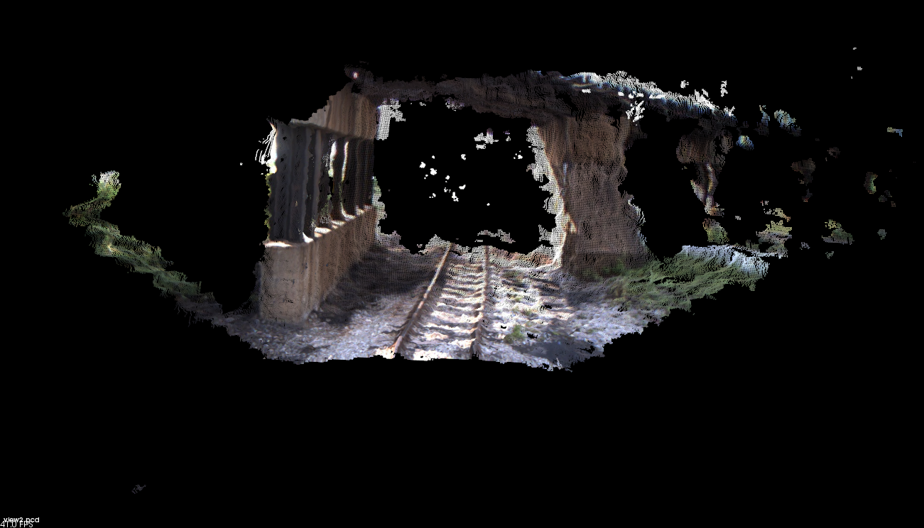

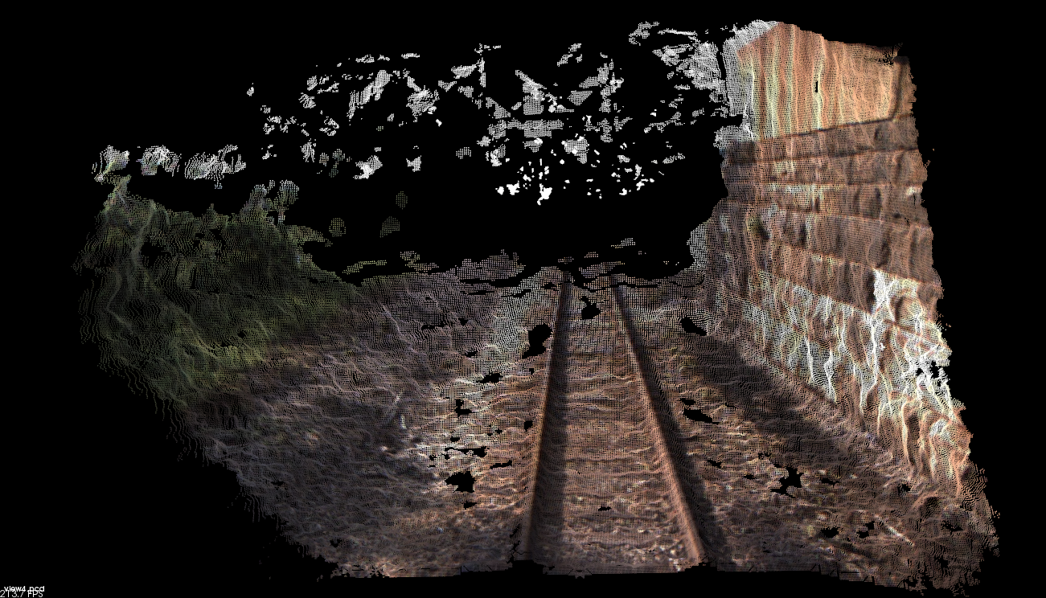

Combined Cloud Image -

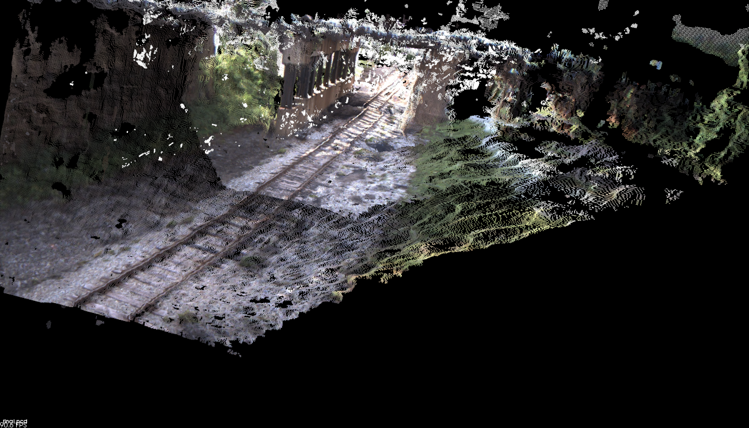

Sincerely,

Mayank Roy